SSD Setup

1. Open Eclipse

2. Click on help-->Install New Software-->Add

Provide Name as: IdentityIQ Deployemnt Accelerator

Location: http://sailpoint.github.io/epiiq

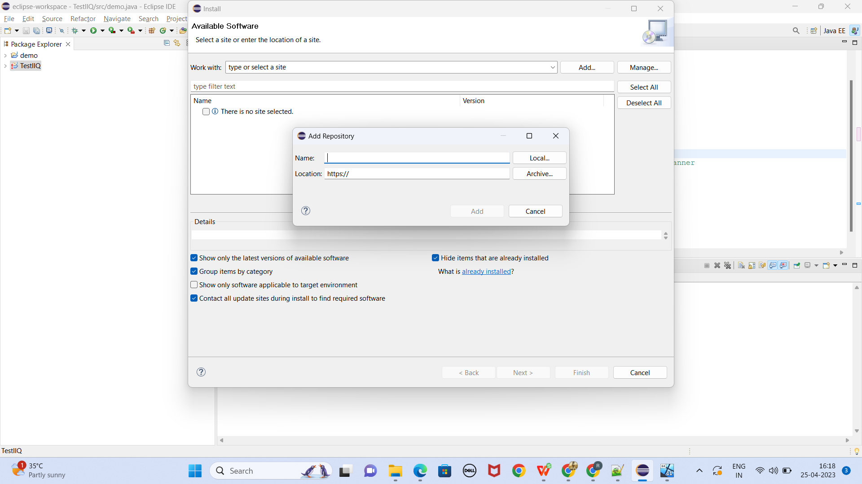

Click on Add select Sailpoint

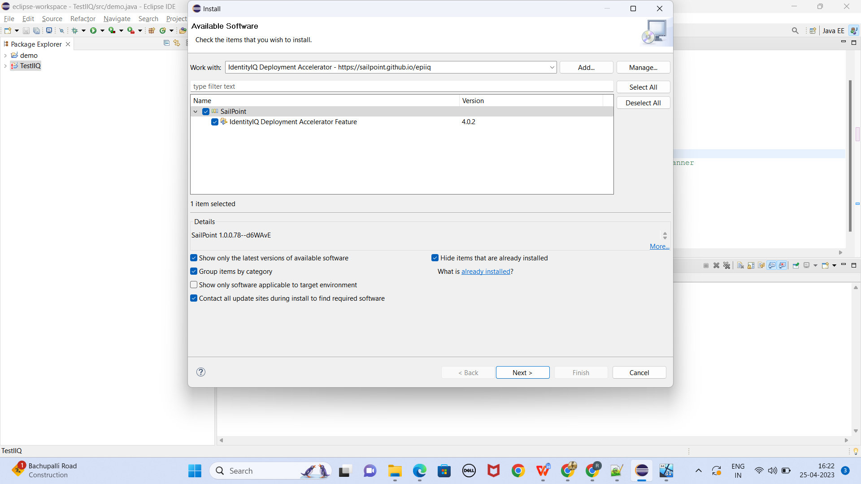

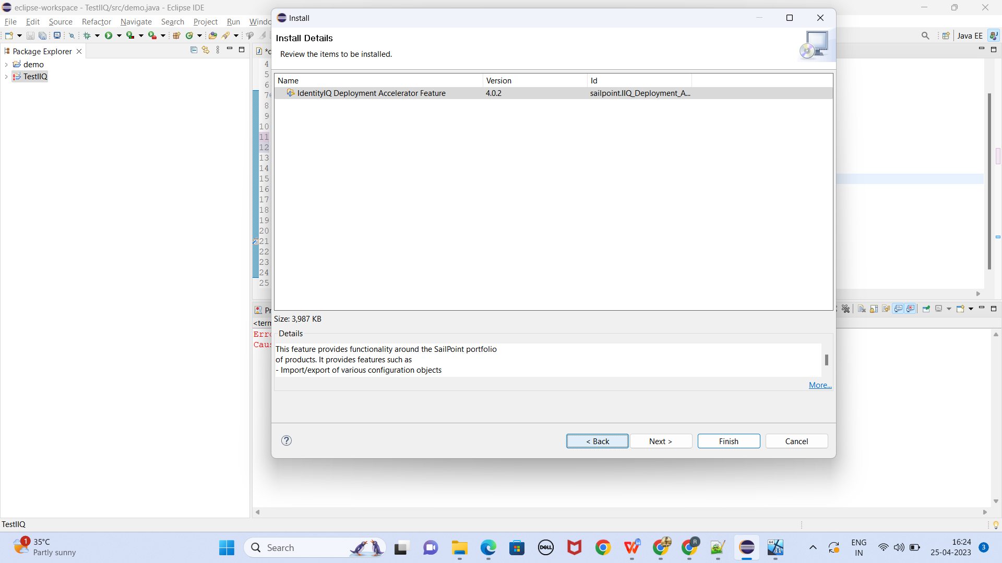

Unzip ssd-v7.zip and point to new Project in eclipse for project creation.

